786
Name: Muhammad Sherjeel Akhtar
Roll No: 20p-0101
Subject: Computer Network Lab
Task No: 8
Submitted To Respect Ma’am: Miss Hurmat Hidayat
Section: B

Question 1:
Answer:
Wireshark:
Wireshark is a free and open source packet analyzer. It is used for network troubleshooting, analysis, software and communications protocol development.
Opening the Wireshark:
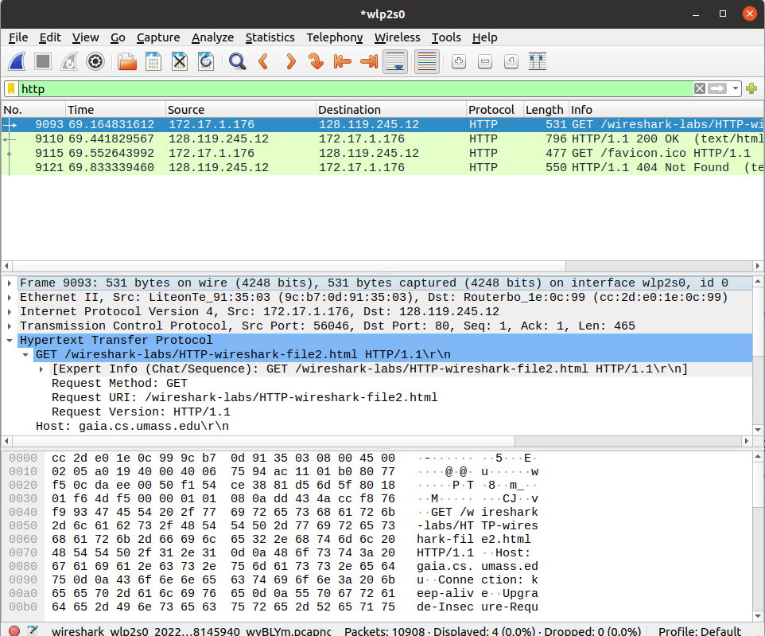
.

First of all open the wireshark.
Opening The Link:
.
This is the link given in the manual, click on it and a web page will open in front
of you.

Observing The Link:
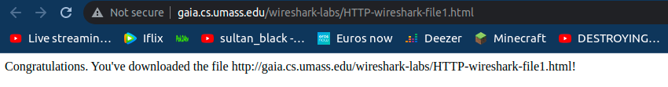
.
Observing The Wireshark:
.
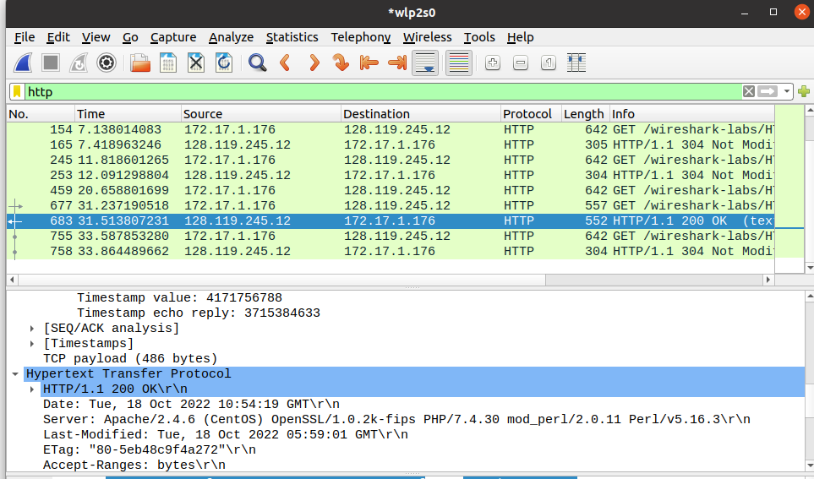
.

.
.
.

This is the data being observed on the wireshark.
You can see, the the 200 OK message in the info of the Wireshark. This is being observed after stoping the wireshark from the bottom Top corner.
Question 2:
Part 1:
Answer:
Checking The Version Of The Browser Running The HTTP:
.
The version of the browser running the HTTP Request is 1.1
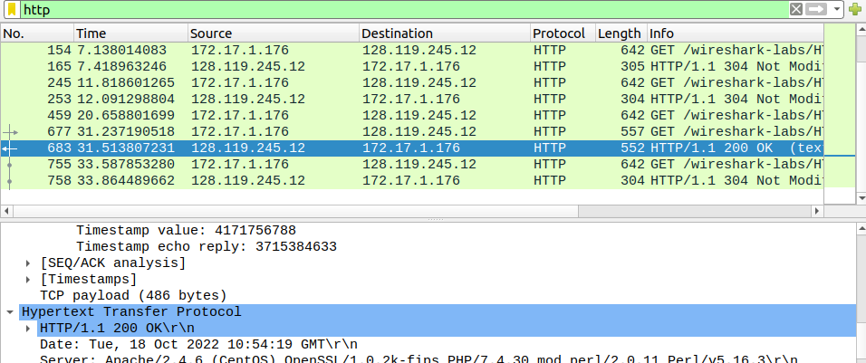
(HTTP/1.1).
Part 2:
Answer:
Version Of The HTTP On Which Server Is Running:
The version of the HTTP on which the server is running is also HTTP/1.1 which is shown below.
.
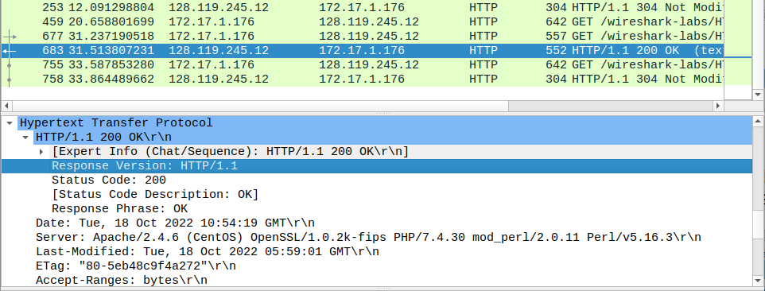
.
Part 3:
Answer:
Language Indicated By The Browser:
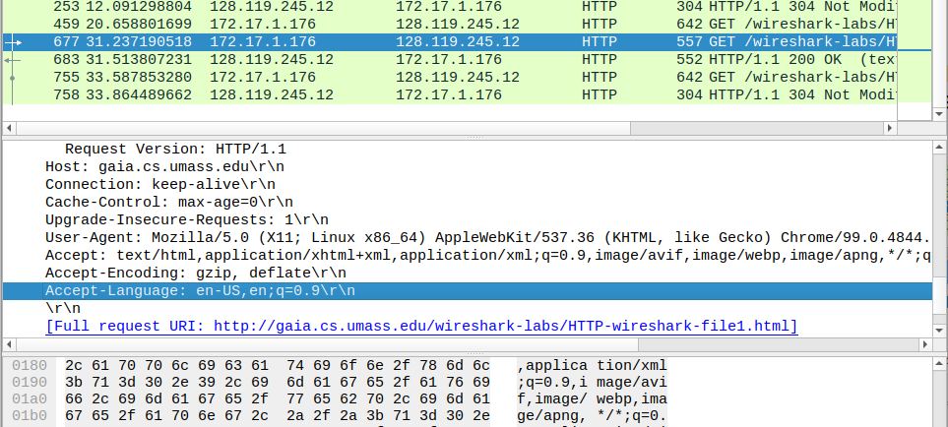
.
You can see the language indicated in the Accept Language.
Part 4:
Answer:
The IP Address of the server and IP Address of the computer are attached in the picture below.
They are represented as source and destination IP’s.
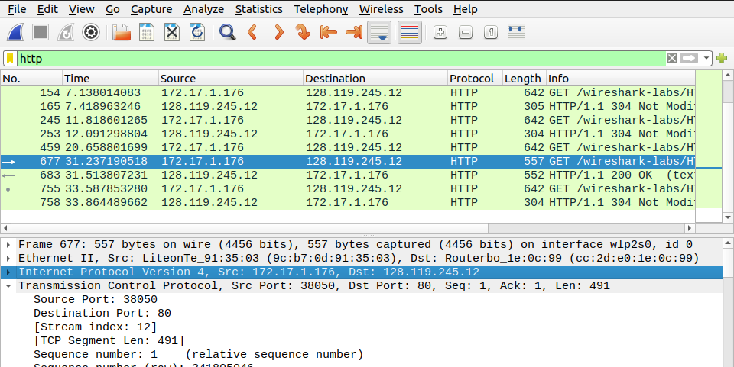
.

Part 5:
Answer:
Status Code Returned:
The browser will return a status code of “200 OK”.
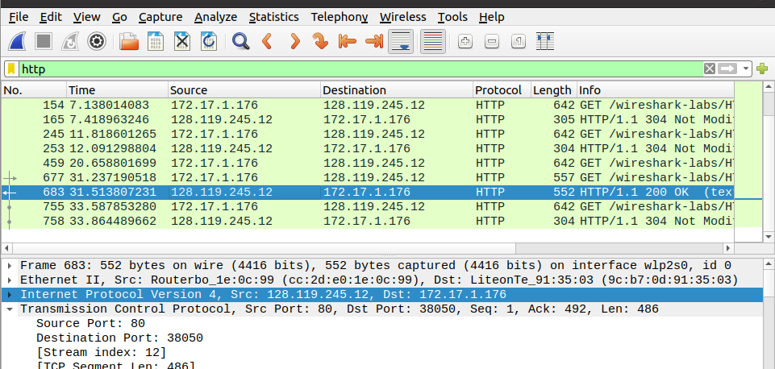
.
Part 6:
Answer:
The “Last-Modified” for the HTML file for the server is displayed in the picture below:
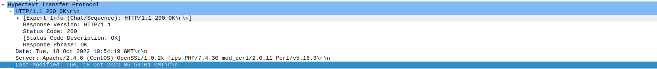
.
Part 7:
Answer:
The bytes of content returned to our browser are shown in the picture below.
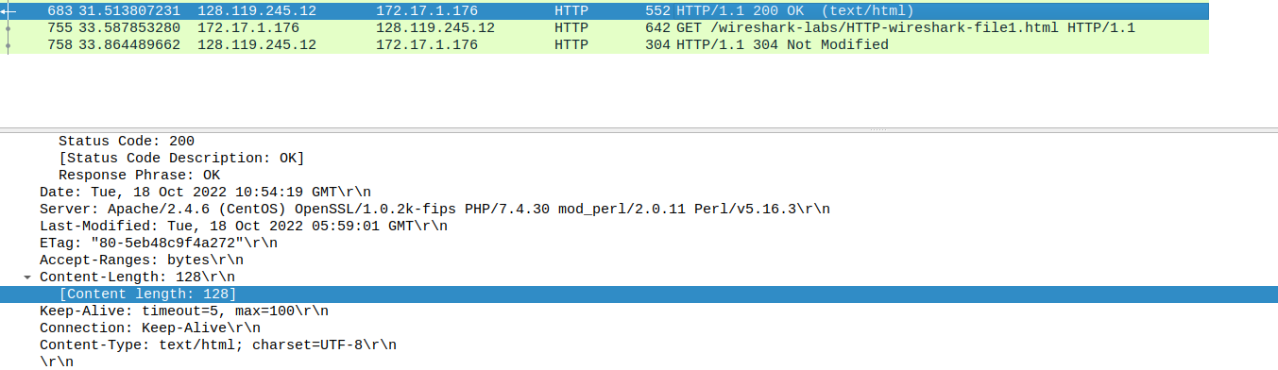
.
Part 8:
Answer:
By inspecting the raw data in the packet content window, it is being observed that no all of the headers can be found in the raw data.
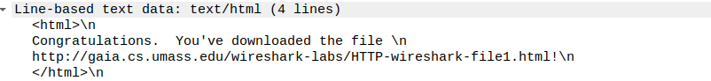
Question 3:
Part 1:
Answer:
We’ve inspected the contents of the first HTTP Get Request from our browser to the server. We’ve not seen any “IF-Modified” since we’ve observed the first line in the HTTP Get.
Demonstration From The Screenshot:
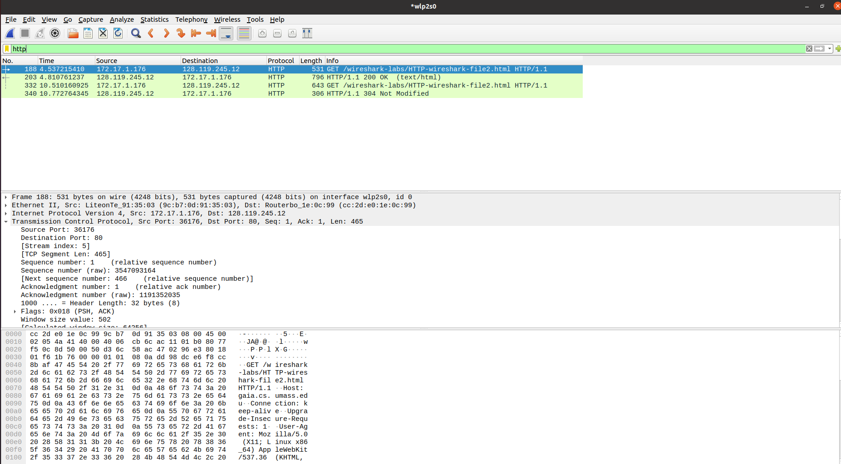
.
Here you can see, no if-modified in the first line.
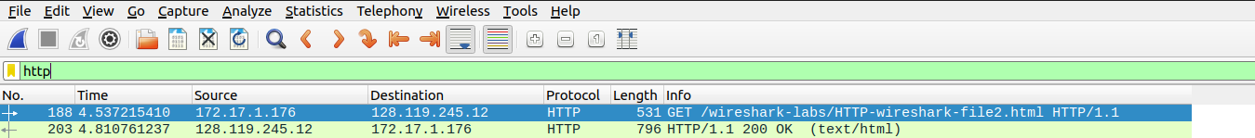
.
Part 2:
Answer:
Yes the server explicitly return the contents of the file. Here is the visual demonstration of the response in the picture below.
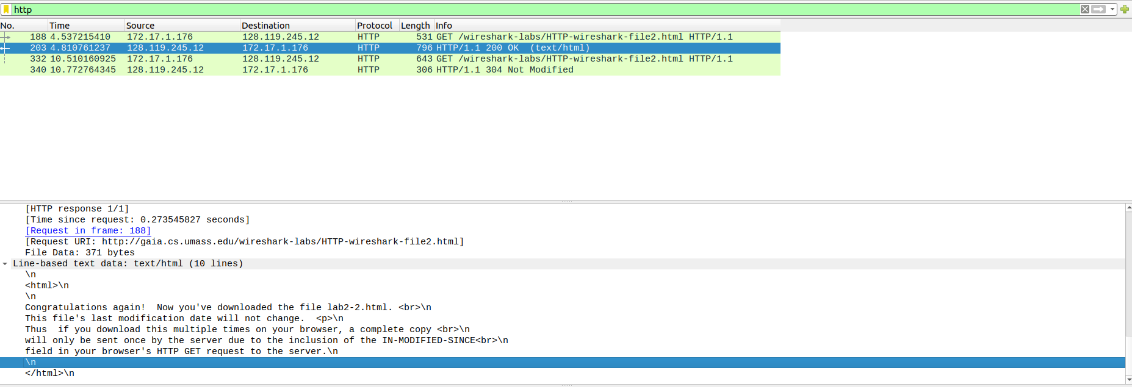
.
Part 3:
Answer:
Yes, we’ve observed the “IF-Modified-Since” in the HTTP GET6 as mentioned in the picture below.
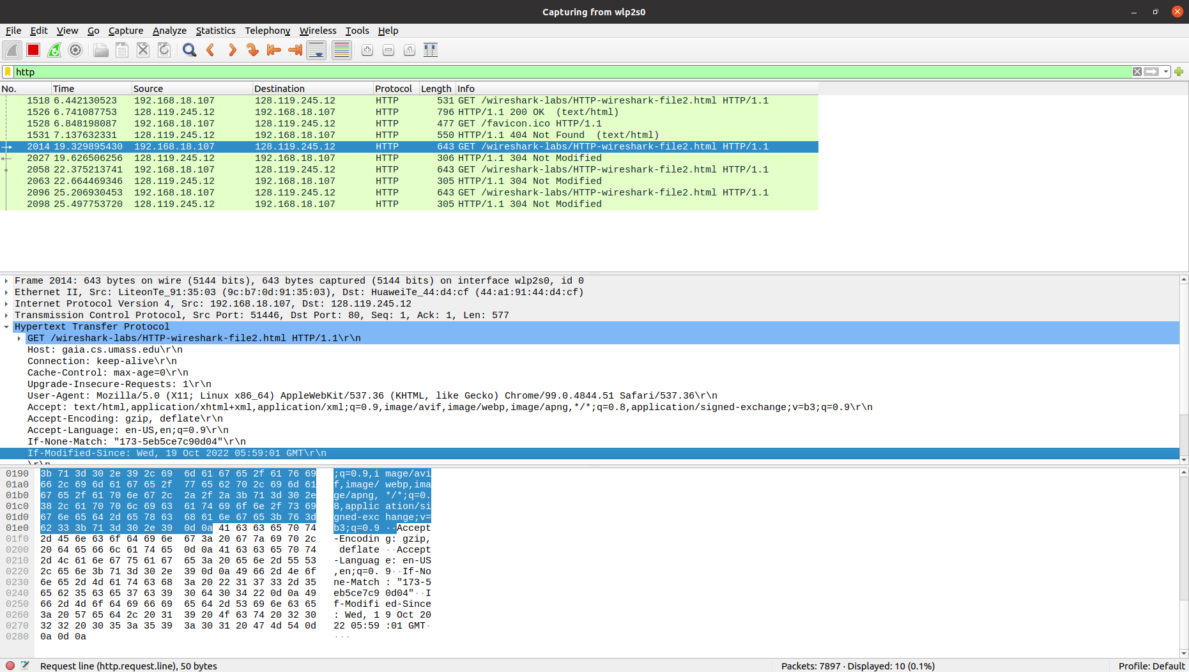
.
Part 4:
Answer:
Reasoning:
The browser did not return the contents of the file explicitly. This is because the browser is retrieving its contents from its cache. The file has been modified since it was last accessed, therefore it is simply showing to retrieve the old file from the cache memory.
Visual Demonstration:
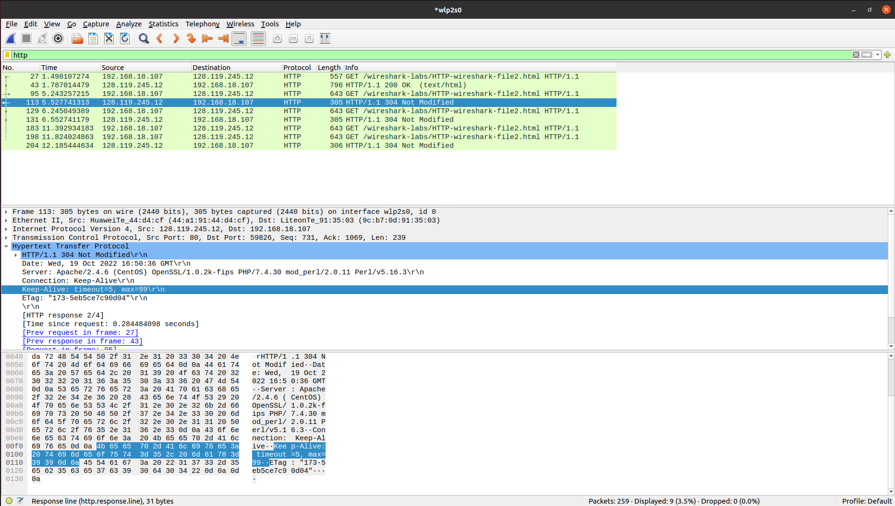
.
This can be observed by having a look at the,
“ETag:” and “Keep-Alive” Data.

